ICCS Awards Reception
University of Ottawa, June 11, 2016
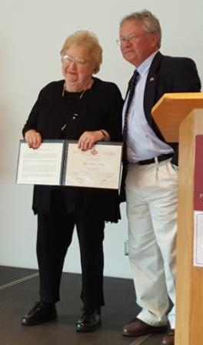
Former ACSUS President Myrna Delson-Karan receives congratulations from current President Munroe Eagles upon winning the ICCS “Certificate of Merit”

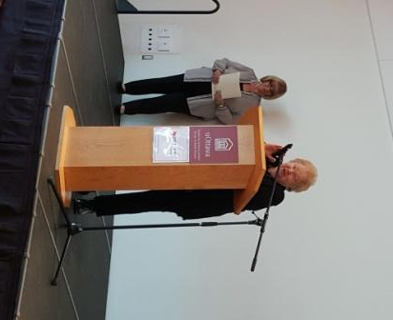
Myrna Delson-Karan accepting the ICCS Certificate of Merit. ICCS President Susan Hodgett is in the background.
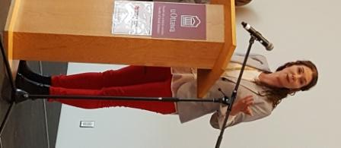
Elizabeth Goodyear-Grant accepts the Pierre Savard Award for the best book published in English/French.

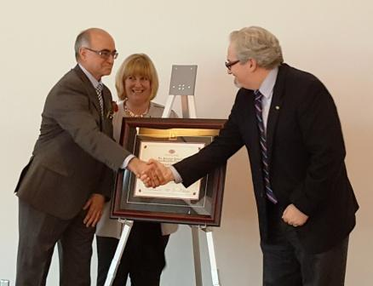
Alain-G. Gagnon accepts congratulations from his Dean, with ICCS President Susan Hodgett looking on, for winning the 2016 “Governor-General’s Award for Canadian Studies”

